GCP BIGQUERY - ASSIGNMENT

HCL ID: HCLTFP2170249

Name: DHARUN P

Roll Number: 23BTRCL014

College Name: Jain University

Batch: 2027

Creating Database – ECOMMERCE Database with Table Entries
Query:
CREATE SCHEMA IF NOT EXISTS `ecommerce`
OPTIONS(location = 'US');

CREATE TABLE IF NOT EXISTS `ecommerce.orders` (
order_id STRING,
customer_id STRING,
order_date DATE,
product_id STRING,
product STRING,
quantity INT64,
unit_price FLOAT64,
region STRING,
status STRING
);

INSERT INTO `ecommerce.orders`
(order_id, customer_id, order_date, product_id,
product, quantity, unit_price, region, status)

VALUES
('O001','C001','2026-08-05','P101','Laptop',1,55000,'South','Delivered'),
('O002','C001','2026-09-10','P102','Mouse',2,800,'South','Delivered'),
('O003','C001','2026-10-12','P101','Laptop',1,55000,'South','Delivered'),
('O004','C002','2026-08-15','P103','Keyboard',1,1500,'North','Delivered'),
('O005','C002','2026-09-16','P104','Monitor',1,12000,'North','Delivered'),
('O006','C002','2026-10-18','P103','Keyboard',2,1500,'North','Delivered'),
('O007','C003','2026-05-02','P101','Laptop',1,55000,'West','Delivered'),
('O008','C003','2026-06-07','P105','Headphones',1,2500,'West','Delivered'),
('O009','C004','2026-10-11','P104','Monitor',2,12000,'West','Delivered'),
('O010','C004','2026-10-22','P106','Tablet',1,20000,'West','Cancelled'),
('O011','C005','2026-04-01','P102','Mouse',1,800,'South','Delivered'),
('O012','C006','2026-10-15','P106','Tablet',1,20000,'South','Delivered'),
('O013','C007','2026-10-20','P105','Headphones',3,2500,'North','Delivered'),
('O014','C008','2026-09-08','P106','Tablet',1,20000,'West','Pending'),
('O003','C001','2026-10-12','P101','Laptop',1,55000,'South','Delivered');
Output:
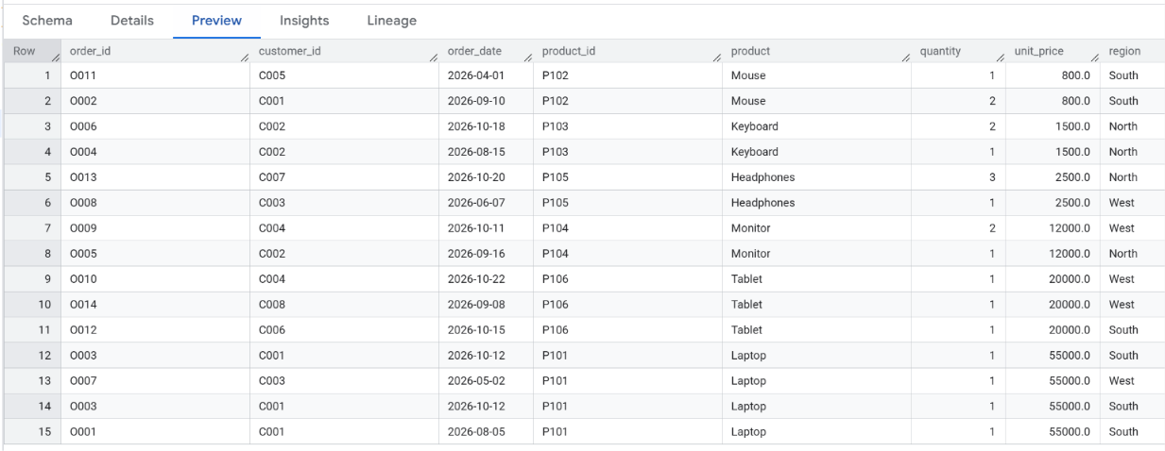
TASK 01: Remove the Duplicate Orders
Query:
SELECT DISTINCT *
FROM `ecommerce.orders`
ORDER BY order_id;

Output:
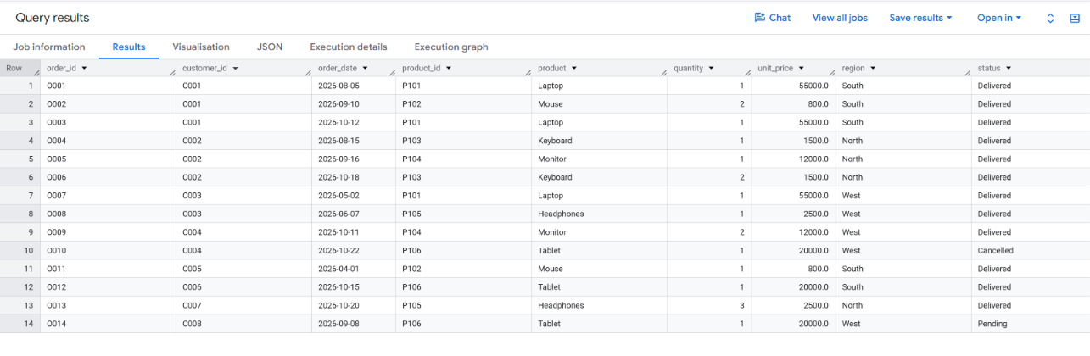

TASK 2: Find the Net Revenue
Query:
SELECT
ROUND(SUM(quantity * unit_price), 2)
AS net_revenue
FROM (
SELECT DISTINCT *
FROM `ecommerce.orders`
)
WHERE status = 'Delivered';

Output:
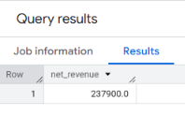
TASK 03: Find the Top 3 Products in each Region
Query:
SELECT
product,
region
FROM (
SELECT
product,
region,
SUM(quantity * unit_price) AS total_sales
FROM (
SELECT DISTINCT *
FROM `ecommerce.orders`
)
WHERE status = 'Delivered'
GROUP BY product, region
)
QUALIFY ROW_NUMBER() OVER (
PARTITION BY region
ORDER BY total_sales DESC, product
) <= 3
ORDER BY region, total_sales DESC;

Output:
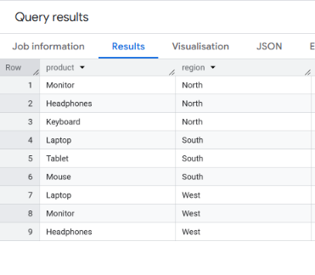
TASK 4: Identify Inactive Customers
Query:
WITH customer_activity AS (
SELECT
customer_id,
MAX(
CASE
WHEN status = 'Delivered'
THEN order_date
END
) AS last_purchase_date
FROM (
SELECT DISTINCT *
FROM `ecommerce.orders`
)
GROUP BY customer_id
)

SELECT *
FROM customer_activity

WHERE last_purchase_date <
DATE_SUB(CURRENT_DATE('Asia/Kolkata'), INTERVAL 90 DAY)
OR last_purchase_date IS NULL

ORDER BY last_purchase_date;

Output:
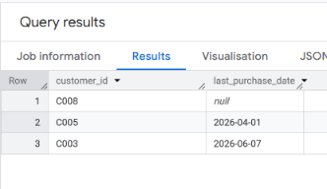
TASK 5: Find the Customers who Purchase Continuously 3 Months
Query:
WITH monthly_orders AS (
SELECT DISTINCT
customer_id,
DATE_TRUNC(order_date, MONTH) AS month
FROM `ecommerce.orders`
WHERE status = 'Delivered'
),

purchase_history AS (
SELECT
customer_id,
month,
LAG(month, 1) OVER (
PARTITION BY customer_id
ORDER BY month
) AS previous_month,
LAG(month, 2) OVER (
PARTITION BY customer_id
ORDER BY month
) AS two_months_ago
FROM monthly_orders
)

SELECT
customer_id,
two_months_ago AS first_month,
previous_month AS second_month,
month AS third_month
FROM purchase_history

WHERE previous_month =
DATE_SUB(month, INTERVAL 1 MONTH)

AND two_months_ago =
DATE_SUB(month, INTERVAL 2 MONTH)

ORDER BY customer_id;

Output:
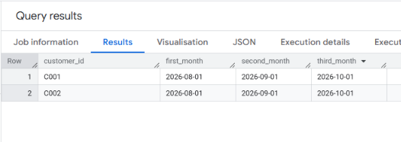
TASK 6: Build a Customer Lifetime Value Report
Query:
SELECT
customer_id,
COUNT(DISTINCT order_id) AS total_orders,
SUM(quantity) AS total_quantity,
ROUND(SUM(quantity * unit_price), 2)
AS customer_lifetime_value,
ROUND(
SAFE_DIVIDE(
SUM(quantity * unit_price),
COUNT(DISTINCT order_id)
), 2
) AS average_order_value,
MIN(order_date) AS first_purchase,
MAX(order_date) AS last_purchase

FROM (
SELECT DISTINCT *
FROM `ecommerce.orders`
)

WHERE status = 'Delivered'

GROUP BY customer_id

ORDER BY customer_lifetime_value DESC;
Output:
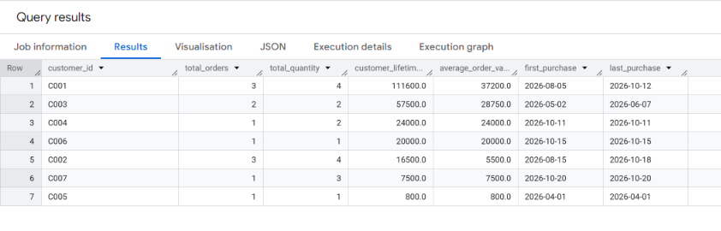
TASK 7: Find the Monthly Sales
Query:
SELECT
FORMAT_DATE('%Y-%m', order_date) AS sales_month,
COUNT(DISTINCT order_id) AS total_orders,
SUM(quantity) AS total_quantity,
ROUND(SUM(quantity * unit_price), 2)
AS monthly_sales

FROM (
SELECT DISTINCT *
FROM `ecommerce.orders`
)

WHERE status = 'Delivered'

GROUP BY sales_month

ORDER BY sales_month;
Output:
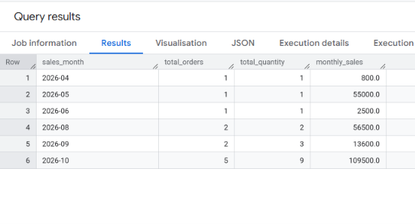
TASK 8: Find the Unit Price Below 10000 in a Particular Month
Query:
SELECT DISTINCT
order_id,
customer_id,
order_date,
product,
quantity,
unit_price,
region

FROM `ecommerce.orders`

WHERE unit_price < 10000

AND EXTRACT(MONTH FROM order_date) = 10
AND EXTRACT(YEAR FROM order_date) = 2026

ORDER BY unit_price ASC;
Output:
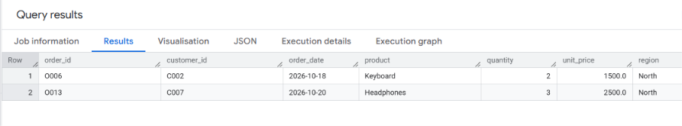

TASK 09: Find the Customer who is Purchased Particular Product Multiple Times in 6 Months
Query:
SELECT
customer_id,
product,
COUNT(DISTINCT order_id) AS purchase_count,
SUM(quantity) AS total_quantity,
ROUND(SUM(quantity * unit_price), 2)
AS total_spent

FROM (
SELECT DISTINCT *
FROM `ecommerce.orders`
)

WHERE product = 'Laptop'
AND status = 'Delivered'

AND order_date BETWEEN
DATE_SUB(
CURRENT_DATE('Asia/Kolkata'),
INTERVAL 6 MONTH
)
AND CURRENT_DATE('Asia/Kolkata')

GROUP BY customer_id, product

HAVING COUNT(DISTINCT order_id) > 1

ORDER BY purchase_count DESC;

Output:
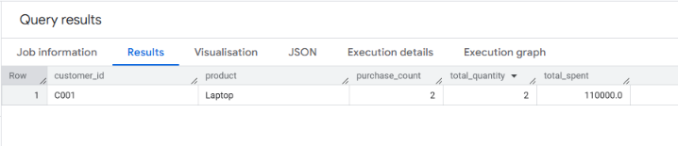

TASK 10: Find the Total Sales Report for each Product in a Particular Month
Query:
SELECT
product_id,
product,
COUNT(DISTINCT order_id) AS total_orders,
SUM(quantity) AS total_quantity,
ROUND(SUM(quantity * unit_price), 2)
AS total_sales

FROM (
SELECT DISTINCT *
FROM `ecommerce.orders`
)

WHERE status = 'Delivered'

AND EXTRACT(MONTH FROM order_date) = 10
AND EXTRACT(YEAR FROM order_date) = 2026

GROUP BY product_id, product

ORDER BY total_sales DESC;

Output:
